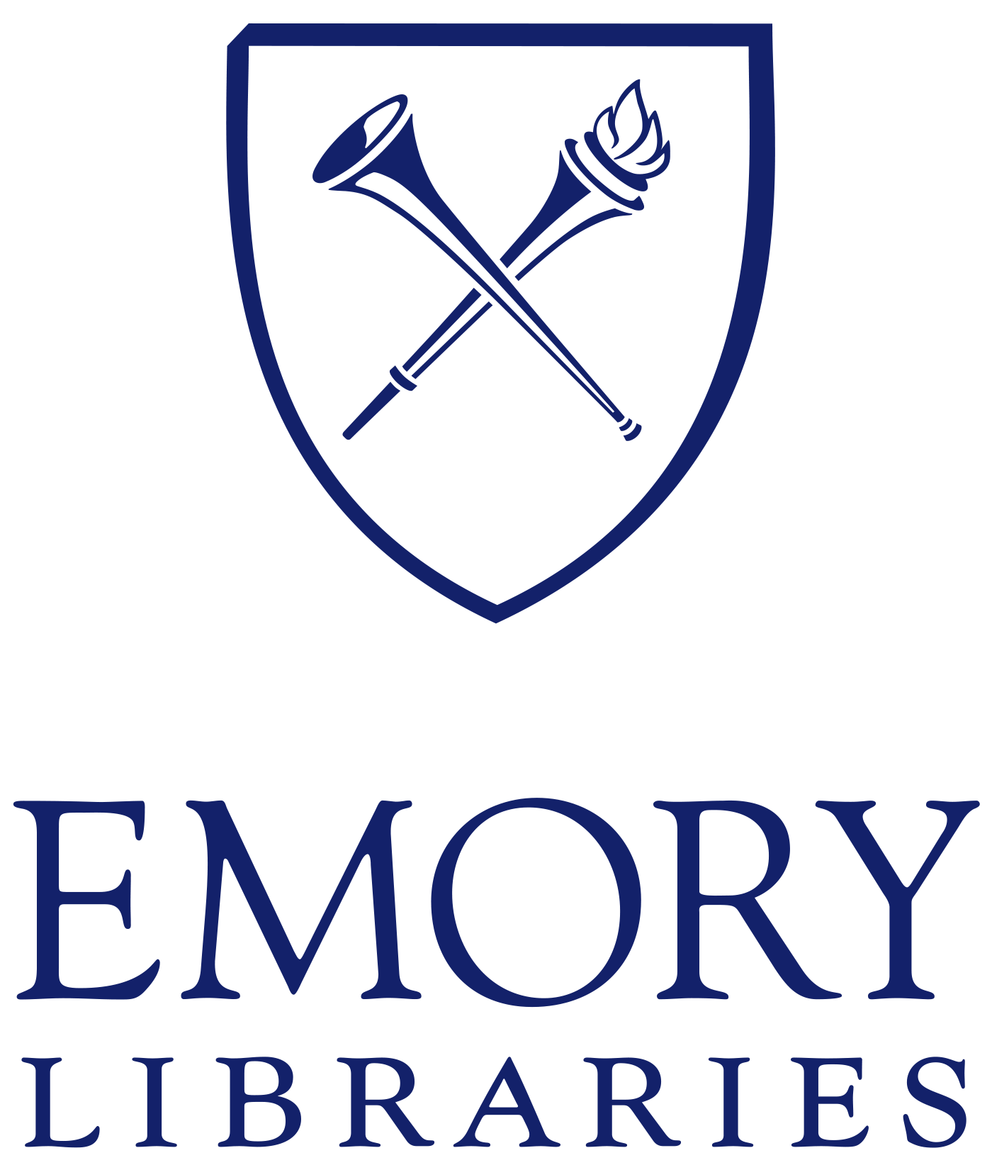 | Libraries Human Resources  Professional Position Posting

Sr Dir, Communications, Marketing, and Public Relations (EL&MCCM)

Department: Emory Libraries & Carlos Museum

Salary: Commensurate with qualifications and experience

Position Availability: Immediately

Location: Atlanta, GA

Position Summary
The Senior Director for Communications, Marketing, and Public Relations will work across the University to promote and strengthen the reputation, brand, and visibility for Emory Libraries and the Michael C. Carlos Museum (EL&MCCM) locally, nationally, and internationally. In collaboration with the University’s emerging communications structure, the individual in this role will ensure that EL&MCCM initiatives and activities are aligned with the institution’s six pillars, mission, and vision. Reporting to the Vice Provost, Libraries and Museum, the successful candidate must be a collaborative, strategic leader whose primary focus is on development of strategies to elevate the EL&MCCM brand. The Sr Director will have a close working relationship with the Museum Director and the University Librarian. The successful candidate will build strong relationships with the appropriate contacts for Emory’s Office of Communications and act as a liaison to both internal and external constituents including but not limited to Advancement and Alumni Relations, Office of the President, Office of the Provost, Campus Life, Emory Arts, Religious Life, civic and community organizations, the City of Atlanta and beyond. Will be responsible for assessing the effectiveness of the current EL&MCCM framework for communications, guiding the work of the library and museum communications and marketing teams, and integrating Emory’s six One Emory: Ambition & Heart pillars into all work. Must have strong analytical skills and a data-oriented decision-making approach; ability to think strategically and develop and communicate a shared vision; ability to demonstrate cultural awareness and agility; exercise emotional intelligence, build trust and credibility, and manage change in a complex organization; and ability to tolerate change and uncertainty within an emerging organizational structure.

Emory Libraries requires that our employees recognize diversity, equity, and inclusion as essential core values to achieving our mission to enrich the quality of life in an inclusive work environment through competency training, reassurance of personal growth, restorative communication practices, and embrace our diverse identities of patrons within the Emory community.
This position’s responsibilities and duties are required to be performed in-person at an Emory University location, Robert W. Woodruff Library and Carlos Museum. Remote work from home day options may be granted at department discretion. Emory reserves the right to change remote work status with notice to employee.

Essential Responsibilities & Duties
- Oversee the marketing, communications, and public relations activities of the libraries and museum. Use data-informed practices to elevate the EL&MCCM brand regionally, nationally, and globally. Will work to broaden stakeholder groups.
- Develop a strategic marketing and communications approach and recommend and implement engagement and campaigns that connect institutional and EL&MCCM priorities with audiences to spur a response.
- Develop a vision for leveraging demographically relevant marketing and promotional messaging with a heavy focus on social and new media.
- Develop a vision for and oversee the work of the marketing and communications teams in both the libraries and museum. May restructure as necessary. These teams are charged in part with:
  - Developing and implementing media relations and/or publications programs and overseeing media relations and/or publications for libraries and the museum
  - Assisting in strategic public relations planning and implementation including media relations, publications and periodicals, crises communication and issues management.
  - Developing relationships with journalists and content creators and overseeing and implementing new methods for media relations.
  - Public programming (libraries), exhibitions (libraries), and community relations.
- Provide guidance on best use of marketing, communications, and PR budget.
- Collaborate closely with Emory’s Communications and Marketing as well as other units such as Advancement and Alumni relations to ensure consistent and coordinated messaging and brand alignment across all audiences.
- Performs other related duties as required.

MINIMUM QUALIFICATIONS:
A bachelor’s degree in related field and five years of directly relevant experience, OR an equivalent combination of education, training, and experience. Experience in communications, public relations, marketing, art or other related field. Five years of experience in the development of marketing and informational materials, writing/research, project management and/or information technology, and social media platforms. Demonstrated success in developing and implementing a broad range of communication, PR, and marketing initiatives in a complex higher ed environment, cultural heritage, or not-for-profit institution, requiring coordination and strategic leadership of a diverse range of stakeholders. Ability to foster constructive dialogue with different groups across campus, establish ongoing communication structures, and work in collaboration with a wide variety of stakeholders to ensure an inclusive environment. Experience or familiarity with qualitative and quantitative data collection tools (focus groups, surveys, etc.) to interrogate communications and public perception states and use data-driven dashboards to collect, analyze, and present this information. Excellent leadership, interpersonal, and oral and written communication skills, and ability to influence and inspire others. Experience and demonstrated skill in supervision, including hiring, orienting, training and development, organizing workloads, delegating responsibility, providing guidance and direction, monitoring, and evaluating performance, coaching, and counseling, and taking disciplinary action as necessary. Ability to be proactive, flexible, and collaborative as a supervisor to accomplish departmental, library, and institutional goals.

PREFERRED QUALIFICATIONS:
Graduate degree, such as Master’s or Doctorate, in related fields of study.

Application Procedures
Interested candidates should review the applications requirements and apply online at {Link to iCIMS posting}, Requisition/Job Posting #115649

Applications may be submitted as Word or PDF attachments and must include:

- Current resume detailing education and relevant experience.
- Cover letter of application describing qualifications and experience; and
- This is a key leadership position in Emory Libraries and Carlos Museum that manages and leads a diverse, service-oriented team. In a separate statement, please share your management and leadership philosophy, including how you would foster diversity, equity, and inclusion at Emory University Libraries and Carlos Museum. Please limit your response to no more than 3 paragraphs;
- On a separate document list the names, relationships, email addresses, and telephone numbers of 3 professional references including a current or previous supervisor.

General Information
Professional librarians at Emory Libraries are 12-month faculty-equivalent positions evaluated annually with assigned ranks renewable for 3 or 5 years based on experience and background. Appropriate professional leave and funding is provided. Depending on educational credentials and position, librarians may be considered for a shared/dual appointment between the library and academic department as a faculty member.

Librarian appointees at Emory generally have educational credentials and professional backgrounds with academic library experience and/or disciplinary knowledge and demonstrate a commitment to continuous learning, professional engagement and involvement, research and scholarship, creativity, innovation, and flexibility. Such backgrounds will normally include a graduate degree from an ALA-accredited library and information science program AND/OR a discipline-specific master’s OR doctoral degree. In addition to professional competence and service within the library in the primary job assignment, advancement and/or appointment renewal requires professional involvement and contributions outside of the library and scholarly activities. Candidates must show evidence or promise of such contributions.

Emory provides an extremely competitive fringe benefit plan that includes personal leave, holiday pay, medical and dental plans, life insurance, courtesy scholarships, and tuition reimbursement just to name a few. For a full list of benefit programs, please go to http://www.hr.emory.edu/eu/benefits/.

Description of Institution and Library
Emory University is internationally recognized for its outstanding liberal arts college, superb professional schools, and one of the South’s leading health care systems. Emory’s beautiful, leafy main campus is located in Atlanta’s historic Druid Hills suburb and is home to 8,079 undergraduates and 7,372 graduate and professional students. As the second largest private employer in Atlanta, Emory University and Emory Healthcare have a combined workforce of approximately, 37,716 and an annual operating budget of $5.6 billion. Emory University received $831 million in research funding in fiscal year 2020.

Ranked among the top 20 Association of Research Libraries (ARL) in North America, Emory University Libraries in Atlanta and Oxford, Georgia is the interdisciplinary intellectual commons for Emory University. The collections at the nine Emory Libraries include more than 5.6 million volumes, 400,970 electronic journals, over 1.6 million electronic books, and internationally renowned special collections. The Stuart A. Rose Manuscript, Archives, and Rare Books Library is home to over 190,000 cataloged titles and more than 19,000 linear feet of manuscript material. Rose Library’s collections span more than 800 years of history, with particular depth in modern literature and poetry, African American history and culture, political, social and cultural movements, and the University’s archives.

Emory Libraries staff, including student workers, number approximately 350 with an overall library budget of approximately $42 million. Emory University Libraries is a member of the Association of Research Libraries (ARL), the Association of College and Research Libraries (ACRL), the Atlanta Regional Council for Higher Education (ARCHE), the Coalition for Networked Information (CNI), the Center for Research Libraries (CRL), the Council on Library and Information Resources (CLIR), the Digital Library Federation (DLF), International Federation of Library Associations and Institutions (IFLA), and the Scholarly Publishing & Academic Resources Coalition (SPARC) as well as regional associations including the Association of Southeastern Research Libraries (ASERL) and Georgia Library Learning Online (GALILEO).

The Emory University Libraries include the Robert W. Woodruff Library, which is also home to the Goizueta Business Library, the Heilbrun Music and Media Library, and the Stuart A. Rose Manuscript, Archives, and Rare Book Library. Other library spaces include the Science Commons, Cox Hall Computing Center, the Library Service Center operated in collaboration with the Georgia Institute of Technology, the Woodruff Health Sciences Center Library, the Pitts Theology Library, the Hugh F. MacMillan Law Library, and the Oxford College Library located on the Oxford Campus approximately 30 miles from Atlanta.

Diversity Statement
Emory Libraries recognize diversity, equity, and inclusion as core values integral to achieving our mission to enrich the quality of life and advance intellectual discovery by connecting people of diverse backgrounds and experiences. We champion an inclusive work environment through competency training, reassurance of personal growth, restorative communication practices, and diverse recruitment and retention. We offer exhibits, collections, programming, and research assistance that speaks to the rich needs and identities of patrons from the Emory community and beyond. We encompass opportunities that strengthen these values. We invite you to bring your true self to the library and feel welcomed when you arrive.

Emory University is an equal opportunity/equal access/affirmative action employer fully committed to achieving a diverse workforce and complies with all applicable Federal and Georgia State Laws, regulations, and executive orders regarding nondiscrimination and affirmative action in its programs and activities. Emory University welcomes and encourages diversity and does not discriminate on the basis of race, color, religion, ethnic or national origin, gender, genetic information, age, disability, sexual orientation, gender identity, gender expression, and veteran’s status.

– December 2022

